**Practical No 3**

**ORACLE ANALYTICAL QUERIES**

**Q) Implementation of Analytical queries like Roll_Up, Cube, First, Last, Lead, Lag, Rank, Dense Rank, etc.**

**Solution:**

SELECT * FROM EMP;

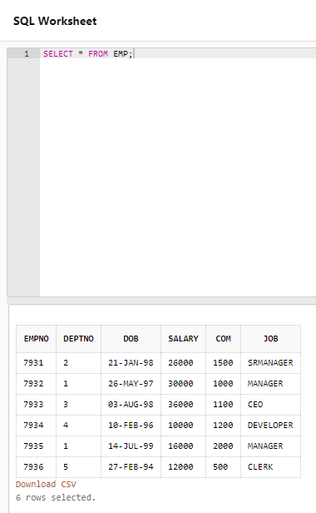



**ROLL_UP:**

SELECT DEPTNO,JOB,COUNT(*),SUM(SALARY)

FROM EMP

GROUP BY ROLLUP(DEPTNO,JOB);

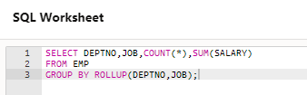

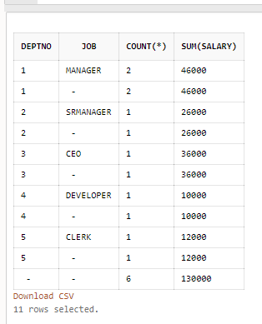

**CUBE:**

SELECT DEPTNO,JOB,COUNT(*),SUM(SALARY)

FROM EMP

GROUP BY CUBE(DEPTNO,JOB);

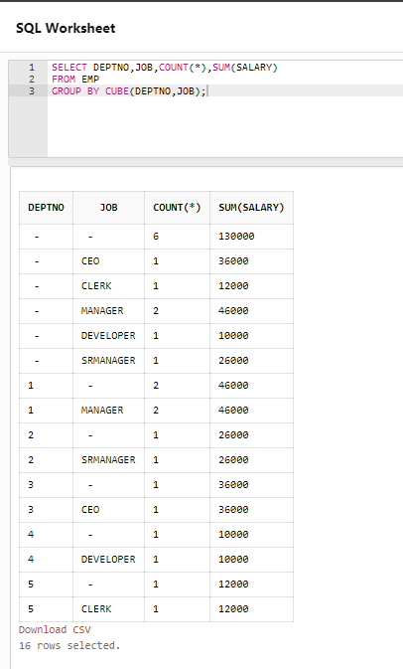



**Rank:**

SELECT EMPNO,DEPTNO,SALARY,COM,

RANK() OVER(PARTITION BY DEPTNO ORDER BY SALARY)AS RANK FROM EMP;

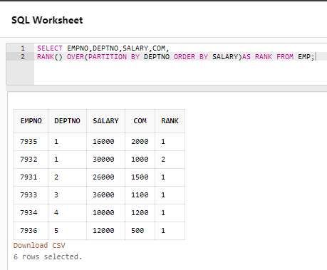



**UPDATE:**

UPDATE EMP

SET SALARY=33000

WHERE EMPNO=7934;

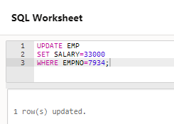

**SELECT:**

SELECT * FROM EMP;

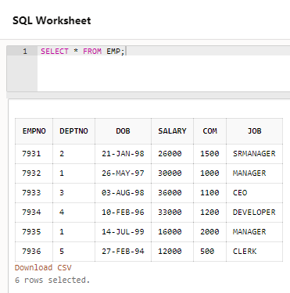

**Dense_rank:**

SELECT EMPNO,DEPTNO,SALARY,COM,

DENSE_RANK() OVER(PARTITION BY DEPTNO ORDER BY SALARY)AS RANK FROM EMP;

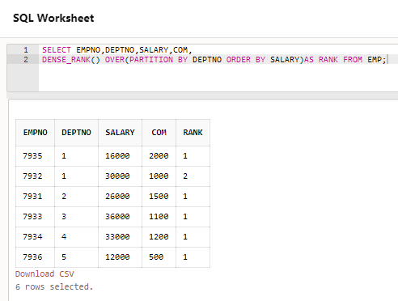

**LEAD:**

SELECT EMPNO,DOB,LEAD(DOB,1)

OVER(ORDER BY DOB) AS "NEXT" FROM EMP;

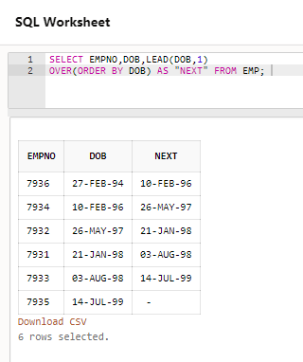

SELECT EMPNO,DOB,LEAD(DOB,1)

OVER(ORDER BY DOB) AS "NEXT" FROM EMP WHERE DEPTNO=1;

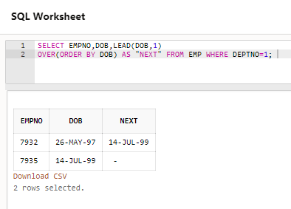

**LAG:**

SELECT EMPNO,DOB,LAG(DOB,1)

OVER(ORDER BY DOB) AS "PREVIOUS" FROM EMP;

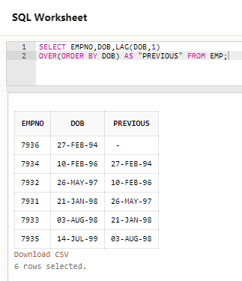

SELECT EMPNO,DOB,LAG(DOB,1)

OVER(ORDER BY DOB) AS "PREVIOUS" FROM EMP WHERE DEPTNO=2;

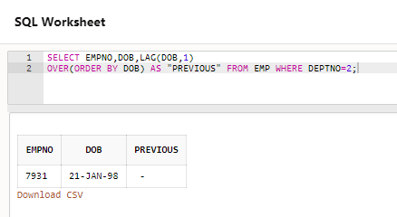

**FIRST:**

SELECT DEPTNO,SALARY,MAX(SALARY)KEEP(DENSE_RANK FIRST ORDER BY SALARY DESC)

OVER(PARTITION BY DEPTNO)"MAX" FROM EMP;

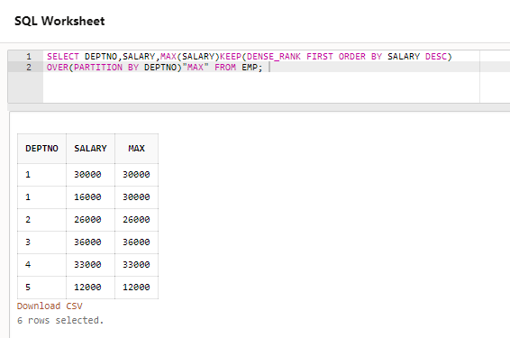

**LAST:**

SELECT DEPTNO,SALARY,MIN(SALARY)KEEP(DENSE_RANK LAST ORDER BY SALARY DESC)

OVER(PARTITION BY DEPTNO)"MIN" FROM EMP;

